**CREATIVE EDUCATIONAL SERVICES**

**BEGINNING OF TERM I EXAMINATIONS 2025**

**LEARNING AREA 2: ENGLISH**

**TOP CLASS**

**Name:……………………………………………………Class: ……….………..……**

**School: ………………………………..…………………………..…………………..**

1. **Colour the picture for the letter.**

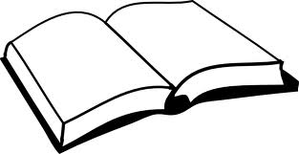b

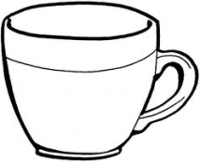

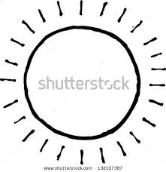

s

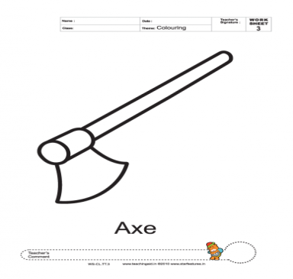

t

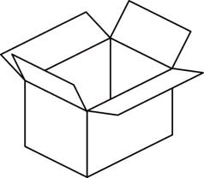

a

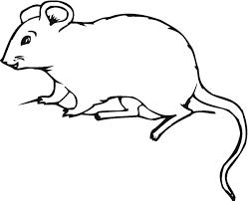

c

1. **Tick the correct word.**

chair ($√$) airch chrai

xob box oxb

bed deb ebd

ucp pcu cup

1. 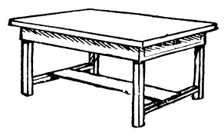**Match the same and draw.**

pot table ________

tin bell ________

bag tin ________

table pot ________

bell bag ________

1. **Write the sentence for the picture.**

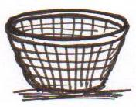

It is a basket.

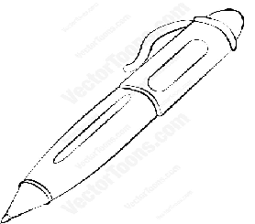

_______________________



________________________



________________________

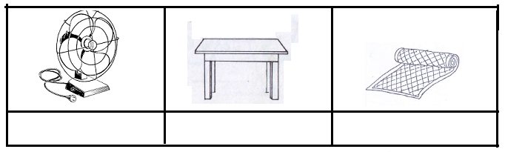

_________________________

1. **Match, name and colour.**

___________

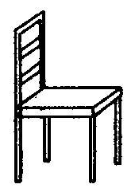

___________



___________





___________



__________

(pencil, tin, chair, table, book)

**End**